[WATERFORD INSTITUTE OF TECHNOLOGY](http://www.university.com)

SEMESTER 2: Assessment 2 (Worth 25% CA)





Electronic Data Interchange (EDI)

Author:

Daire O’Neill

Student Number: 20019346

Course: BSc. in Information Technology

[Southeast Technological University Waterford](http://researchgroup.university.com)

**Declaration of Authorship**

I, Daire O’Neill, declare that this work titled, “Exploring EDI” and the work presented in it are my own. I confirm that:

Where I have consulted the published work of others, this is always clearly attributed.

Where I have quoted from the work of others, the source is always given. With the exception of such quotations, this report is entirely my own work.

I have acknowledged all main sources of help.

Where the report is based on work done by myself jointly with others, I have made clear exactly what was done by others and what I have contributed my-self.

Signed: 





Date: 08/03/23

“We have nothing to fear but fear itself.”

Franklin D. Roosevelt

[South](http://www.university.com)east Technological University Waterford

Abstract

[Department of Computing and Mathematics](http://faculty.university.com)

**Exploring EDI**

By Daire O’Neill

This is a report about exploring EDI, it’s standards, transaction sets, X12, and functional group in EDI. I will talk write about different standards X12 codes and explain how they all come together.

**Table of Contents**

What is the difference between EDI and Edifact standards? 7

Give an example of what a paper purchase order looks like in both standards. 7

In depth explanation of why standards are so important? 8

Explanation of Transaction Sets. Many Transaction Sets can be broken into three parts. Use an example to describe how tables in an X12 Standard document summarize the segments that may be used in each of these three parts of a transaction set. 10

How do you get the X12 standard documents? 10

Give an example of 3 X12 codes and a brief explanation of what they are used for? 11

What is a functional group in EDI? 11

**List of Figures**

Figure 1 An example of an EDI paper purchaser order would be EDI 850 Purchase Order 8

Figure 2 An example of an Edifact paper purchase order is very similar. 9

Figure 3 Diagram: 10

**List of Abbreviations**

EDI: Electronic Data Interchange

EDIFACT: Electronic Data Interchange for Administration, Commerce and Transport

ST: Transaction Set Header

BPR: Beginning Segment for Payment Order

N1: Name

LIN: Item Identification

PID: Product/Item Description

QTY: Quantity

TDS: Total Monetary Value Summary

CAD: Carrier Details

SE: Transaction Set Trailer

20019346 Daire O’Neill



# What is the difference between EDI and Edifact standards?

The main contrast lies in geography, with EDI X12 being predominantly used in North America, especially in the United States, and EDIFACT being more commonly utilized by organizations based in Europe and Asia. The Accredited Standards Committee X12 maintains the standards for EDI X12, whereas The United Nations Economic Commission for Europe and the International Organization for Standardization support EDIFACT's standards. In meeting the healthcare industry's requirements, EDI X12 is employed to create HIPAA-compliant documents, while EDIFACT does not provide HIPAA documents. Although both standards perform data transfer, they differ slightly in terminology and document structures.

# Give an example of what a paper purchase order looks like in both standards.

Figure 1 An example of an EDI paper purchaser order would be EDI 850 Purchase Order

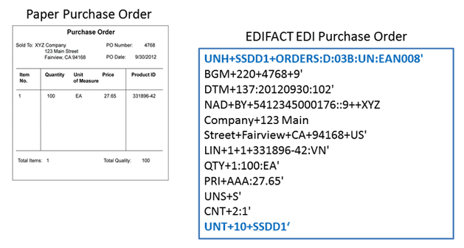

Figure 2 An example of an Edifact paper purchase order is very similar.

# In depth explanation of why standards are so important?

The importance of EDI and Edifact standards lies in their ability to ensure that business documents are exchanged accurately and efficiently between trading partners, regardless of the technology platforms they use. The standardization of codes and message designs allows companies to communicate seamlessly with their partners, reducing the need for manual intervention and increasing the speed and accuracy of data exchange.

Syntax is an important aspect of EDI and EDIFACT standards. Syntax refers to the rules and structure of the data being exchanged. The syntax defines the format of the data, including the order of the data elements, the delimiters used to separate the elements, and the identification values used to identify the data elements.

For example, in an EDIFACT message, the syntax defines the segment structure, which consists of a three-letter segment identifier, followed by a series of data elements separated by a delimiter. The syntax also defines the identification values used to identify each data element, such as the code for the type of document being exchanged, the sender and recipient identification codes, and the date and time of transmission.

The standardization of syntax ensures that trading partners can communicate with each other effectively, even if they use different software systems or platforms. By following a standardized syntax, companies can reduce the risk of errors and misunderstandings in data exchange, improving the efficiency and accuracy of their supply chain processes.

In summary, EDI and EDIFACT standards are essential for modern supply chain management, allowing companies to automate and streamline their business processes. The standardization of syntax, codes, message designs, and identification values ensures that trading partners can communicate with each other effectively, reducing errors, improving efficiency, and lowering costs.

Figure 3 Diagram:

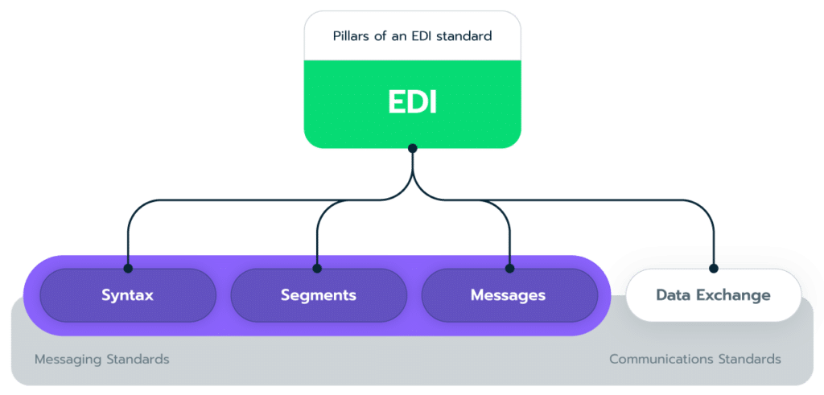

# Explanation of Transaction Sets. Many Transaction Sets can be broken into three parts. Use an example to describe how tables in an X12 Standard document summarize the segments that may be used in each of these three parts of a transaction set.

Transaction sets are a series of (EDI) messages that are used to exchange specific types of business documents between trading partners. Each transaction set is identified by a unique three-digit number and contains a predefined format for the data that will be exchanged.

For example, the 850-transaction set is used for purchase orders, the 810-transaction set is used for invoices, and the 856-transaction set is used for shipping notices. Each transaction set includes a standard set of data elements that are required for the business document being exchanged.

Transaction sets are commonly used in industries such as retail, healthcare, and transportation to facilitate electronic data interchange between trading partners. They help to streamline the exchange of information and reduce errors associated with manual data entry.

Many transaction sets can be broken up into 3 parts: header, details, summary.

X12 is a widely used standard for EDI between businesses. X12 documents are structured into functional groups, which are further divided into transaction sets. Each transaction set contains a series of segments that provide specific information about the transaction being carried out.

In X12 documents, tables are often used to summarize the segments that may be used in each of the three parts: header, details, and summary. Let's consider an example of an X12 810 Invoice document.

The header of an X12 810 Invoice document typically contains information about the sender, recipient, and the type of transaction being conducted. Some of the segments that may be included in the header of an 810 Invoice include ST, BPR and N1.

The details section of an X12 810 Invoice contains the specific line items for the products or services being billed. In the case of an 810 Invoice, the details section would include segments like LIN, PID, and QTY.

The summary section of an X12 810 Invoice contains any additional information or calculations related to the invoice, such as the total amount due. Some of the segments that may be included in the summary of an 810 Invoice include TDS, CAD, and SE.

# How do you get the X12 standard documents?

The X12 standard documents are typically available through the Accredited Standards Committee, which is responsible for developing and maintaining the X12 standards. You can find X12 standard documents at www.x12.org.

# Give an example of 3 X12 codes and a brief explanation of what they are used for?

810 Invoice, 830 Planning Schedule/Material Release, and 850 Purchase Order are three EDI transaction sets commonly used in supply chain management. Here's a brief explanation of each:

810 Invoice: The 810 Invoice is an electronic document that is used to transmit billing information from a supplier to a buyer. This document includes details such as the product or service provided, the price, the payment terms, and any applicable discounts or taxes.

830 Planning Schedule/Material Release: The 830 Planning Schedule/Material Release is an electronic document that is used to communicate the production schedule and material requirements from the buyer to the supplier. This document includes information such as the type and quantity of materials required, the date by which they are needed, and the delivery location.

850 Purchase Order: The 850 Purchase Order is an electronic document that is used to initiate a purchase order between a buyer and a supplier. This document includes information such as the product or service being ordered, the quantity, the price, the delivery location, and the payment terms.

Overall, these three EDI transaction sets help to facilitate the exchange of information and goods between buyers and suppliers, streamlining the supply chain process and improving efficiency.

# What is a functional group in EDI?

In EDI, a functional group is a collection of related transactions or documents that are exchanged between trading partners. A functional group typically contains a header, a trailer, and one or more data segments that represent the individual transactions or documents.

Functional groups are used in EDI to organize and transmit related information in a standardized format. Each functional group is identified by a unique functional group identifier (FGID) that is included in the functional group header.

Functional acknowledgements, also known as 997 acknowledgements, are used in EDI to control the transmission of functional groups between trading partners. A functional acknowledgement is a message that confirms the receipt and processing of a functional group by the receiver. It indicates whether the functional group was successfully processed or if there were any errors that need to be corrected.

When a sender transmits a functional group to a receiver, the receiver responds with a functional acknowledgement. If the functional group was successfully processed, the acknowledgement contains an acceptance message indicating that the functional group was accepted. If there were errors, the acknowledgement contains a rejection message indicating the errors that need to be corrected. Functional acknowledgements play an important role in EDI because they allow trading partners to ensure the accuracy and completeness.

**References**

“EDI Industry Standards | A Crash Course.” *Data Interchange*, https://datainterchange.com/edi-industry-standards/. Accessed 10 April 2023.

“EDI X12 vs. EDIFACT: Learn the Difference.” *GoAnywhere MFT*, 9 December 2019, https://www.goanywhere.com/blog/edi-x12-vs-edifact-whats-the-difference. Accessed 10 April 2023.

O'Neill, Brenda. *Lecturer*. Lecture Notes.

“Transaction Set Envelope.” *IBM*, https://www.ibm.com/docs/en/scbn?topic=envelopes-transaction-set-envelope. Accessed 10 April 2023.

“What Comprises an EDI Document?” *EDI Basics*, https://www.edibasics.co.uk/what-is-edi/what-comprises-an-edi-document/. Accessed 10 April 2023.

“X12 EDI Basics: a Guide to The X12 Standard.” *CData Arc*, https://arc.cdata.com/resources/edi/x12.rst. Accessed 10 April 2023.